LEVEL DESIGN DOCUMENTATION TRACKMANIA LEVEL

Contents

High Level Overview 3
Design Goals 3
Level Goals 3
Design Considerations 3
Key Elements 3
Map Overview 3
Map Structure 3
Layout 3
Beats & Pacing 4
Spatial Design 4
Affordance & Guidance 4
Resources & Pick Ups 4
Points of Interest 4
Challenges & Obstacles 4
Encounters & Enemies 4
Puzzle Design 5
Balance 5
Mission & Narrative 5
Theme & Visuals 5
Narrative Story 5
Mission Design 5
Expected Player Experience 5

High Level Overview

Design Goals
From the design of the level I want to achieve a player experience that is happy with the gameplay of driving. In realistic to unrealistic scenarios. Whilst also having some competition for best lap time.

Level Goals
The objective of the player is to finish the level as fast as possible. Whilst also looking at all possible cuts to be taken drive optimally.

Design Considerations
Some conventions and considerations I will follow will be having a player to make sure they do not crash due to the level. Like when going on a straight road for a long time it will then have a wider turn to turn so player has more space to turn and not crash. Not wanting to have to break for more than a second or two as if I want it as a race map keeping the player in flow. Having arrow signs letting player know turn coming soon. Whilst being in the flow having player make jumps be calculated and not too short. Checkpoints are not where the jump is bit before letting player build up speed again to jump again. Racetrack will be Road having maximum grip level on car.

Key Elements
Key elements I plan to include in my map would be. For enemies there would be environmental hazards and some parts that force the player to set their line perfectly before hitting the block. If player hits wall at full speed they will crash and have the car break and undrivable. For weapons there will be some turbo that will dictate the pace. Pipe sections are in most arcade games which go to extreme speeds by using centrifugal force. It will be a circuit race. Will have buildings and trees to wall in the track giving the player more speed.

Map Overview

Map Structure

Layout
The race layout is a circuit. While using track manias mechanics the car changes gameplay. Meaning there will be multiple different tracks. Starting from stadium, dirt, grass, and snow. On the line there would be an invisible path letting the player know where to keep the flow in by pulling the player towards it. And also, a lot of arrow signs to let the player know where to go. Made it so red arrows mean slow down as danger ahead. Whilst yellow is a small indicator and green is just a turn and direction purposes.

Beats & Pacing
The intro would be fast to get to car into at least third gear. Gets the setting going. In the middle part would have a drift area to go past then follow with a jump. Bit of a side turn then leading to changing into the desert car in the dirt area. Then rally car in the grass following onto the snow car in the icy area. Ending off going back to the stadium car
Having rest beats for players when taking a high turn like the drift area for at least 2 seconds. The end of the race would be the fastest part going full high speed.

Spatial Design
Using the 3D space to get in player’s mind. Narrowing track with scenery like trees, lights and buildings makes the player feel as if they are going faster. After a while, that while has an expansion where the player will see a change into an opening view during a jump to feel like they caught a break in this race.

Affordance & Guidance
Affordance, a slight curve, allows the player to go to high speeds. But a sharp 90-degree turn affords a drift or a sharp break. Directional signage using arrow signs. Will be before the part so player can react to it. Lights having the players’ eye naturally looking at the light and following it.

Resources & Pick Ups
For resources, the most useful one will be the boosts. They are the power ups ensuring the player has enough speed for the next beat. Risky finishes a very narrow gap player must fit in to catch up for a second or two behind.

Points of Interest
Landmarks will be the main POI. Having a large tower in the distance the player uses this to understand where they are in the circuit. A jump over a building makes the map a bit dramatic. Finish line will have a big crowd of people watching so players know that is the end.

Challenges & Obstacles

Encounters & Enemies
The main hazards for the game will be environmental hazards. I used a lot of different types of blockages such as spinning wheels and barrels etc. To give the player a bit more of a thrill and add high stakes to it. The enemy could be the improvement mode. Which is the previous player play time to see how they are doing so it feels like a 1v1. Also surface tensions from all the different car types. All require a different feeling and control over it while not crashing or losing speed.

Puzzle Design
For puzzle design the main things would be avoiding the obstacles in the way. While also using the path the best way at the right times as the rally part for example is meant so player can go left right side to side. Keeping momentum whilst also feeling good about it. Visual cues such as arrow signs and POIs letting player know where to go.

Balance
The balance for this is the buildup. The track starts off with a big jump and simple obstacles on the way. Easing the player into it then slowly starts to pick up with more things on the way. Then with the car changes the complexity ramps up. The respawn for when player crashes made sure it works if player crashes any checkpoints and has the speed needed to continue the rest of the race.

Mission & Narrative

Theme & Visuals
The map setting the theme I got an asset pack that was Olympic themed. So, I had different countries setting that were participants in the Olympics around the stadium car area. Countries being China, France, Brazil, and Greece. The setting is an open world race where different types of races go around.

Narrative Story
The race starts with the introduction being the jump in. Mid-section then going around the dodge car leaving the flow of what has happened so far. The track proceeds to get more challenging track getting tighter. Then the climax being when changing back from snow to stadium car. The loop would be that making the player want to play a second time to try and get a better speed record.

Mission Design
Primary objective is to finish the race by getting to the finish line. Created a line which is designed so that a casual player can finish it without advanced mechanics. With Wide checkpoints do not miss able. And very forgiving reset points. To allow the player to get through the level. Some skilled players can use specific mechanics like air control and control.

Expected Player Experience
The playthrough is split into arcs. With different types of cars which we talked about before. Sequence of events such as speeding turning intersections with turns to keep players separated from fast players to slower ones. The line that shows wide with wider safe turns. And tight lines being more risky and faster. The player is expected to control chaos. Experience starts with high-speed confidence gradually bringing up friction with different surfaces changes. Keeping players adrenaline high finish that encourages high reactions.
Top down-level layout
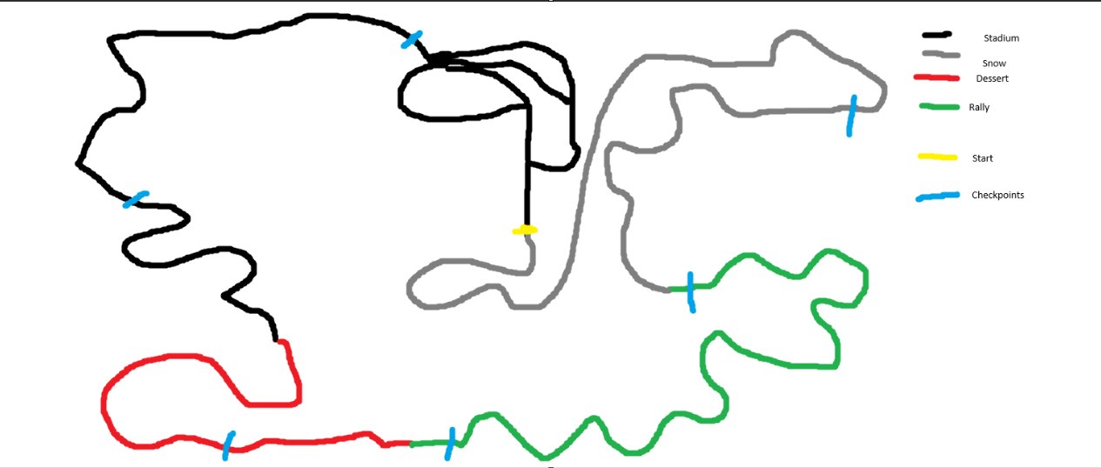
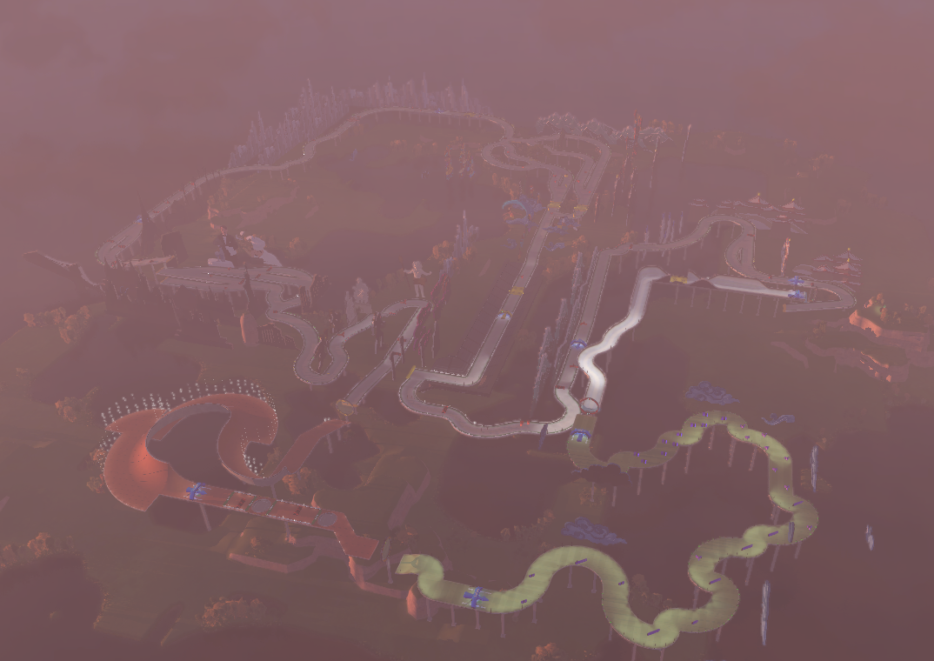

Car change blocks

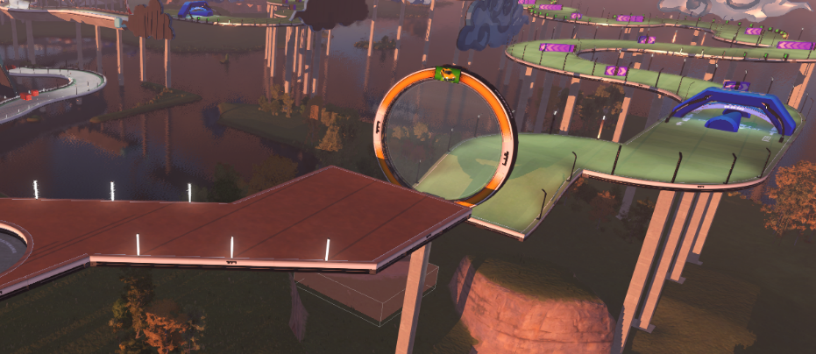
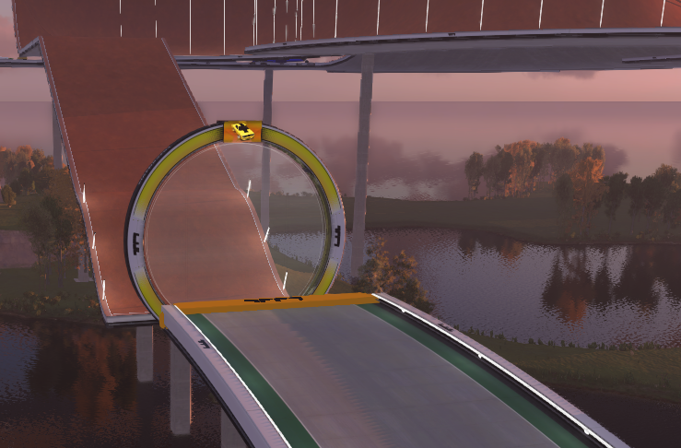

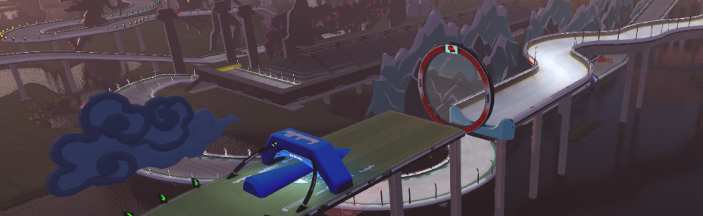
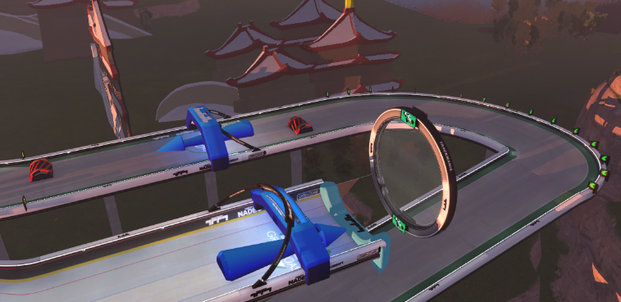

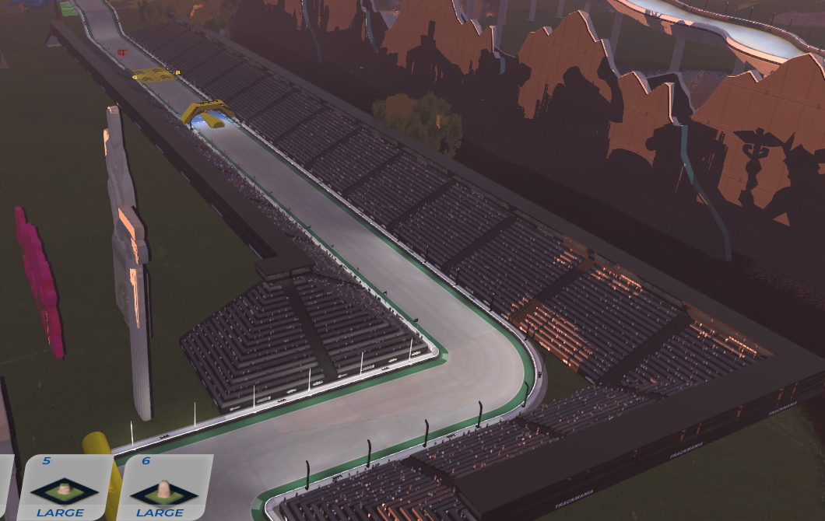
Start / Finish line.

